Finger food menus
4 menus with items in each to choose from
Choose 7 items
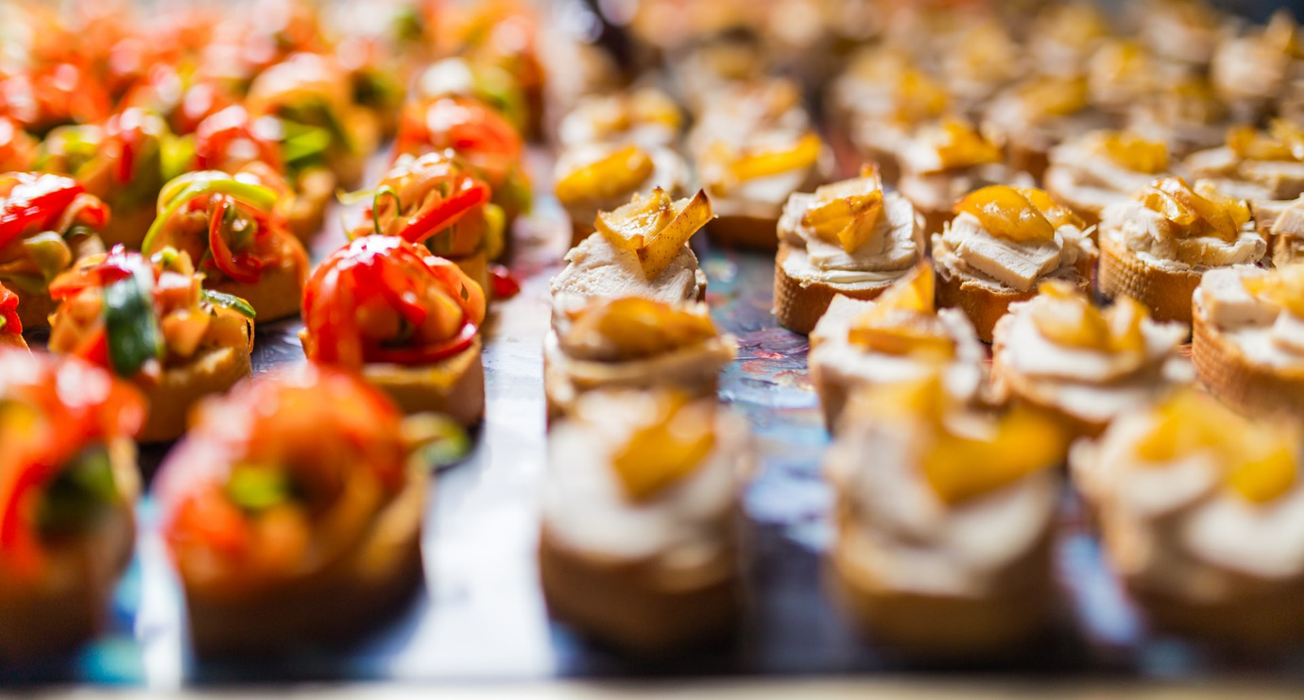

Vegetarian:
Assorted Arancini balls served with Sirach dipping sauce
Mini tacos filled with guacamole, pineapple salsa, sour cream and coriander
Grilled med vegetable and coriander wraps
Roasted Butternut, sweet potato and feta phyllo parcels
Rosa tomato, basil and feta phyllo tarts
Caprese skewers with basil pesto mayo
Butternut, caramelised onion Coos coos and feta wraps
Goats cheese, beetroot, rocket, walnut & honey crostini
Butternut and caramelised onion quiche
Herb crusted haloumi strips and dip
Coriander and re fried beans and brown rice wraps
Thin pastry Savoury Quiche: Camembert & Onion Chutney and Butternut
Camembert Rounds on French bread with a dollop of fig preserve
Sweet corn cakes topped with a fresh avocado salsa and sour cream
Cheese puff pastries
Vegetarian samosas
Vegetable spring rolls with soy sauce & sweet chili sauce
Vegetarian pies
Seafood:
Chilli squid crumbed with dip
Salt and pepper calamari served with aioli sauce
Tempura prawn tails’
Prawn vol au vents with cream cheesed & chives
Hake goujon with tar tar sauce
Lime and chilli marinated Prawn Spikes
Salmon Blinis
Mini crumpets with smoked salmon & crème fraiche
Fish cakes with herbed mayo dip
Kuro Charcoal & Red Velvet Prawns*
Calamari rings with lemon wedges or chilli jam
Beef:
Rump & Apricot kebabs
Mini Beef sliders with Swiss cheese, Bacon and Tomato Relish
Mini vetkoek filled with spicy mince and peppadew
Lasagne béchamel squares
Spicy beef, red pepper and chilli wraps
Shaved Beef fillet topped with caramelised onion and horseradish cream on brochette bread
Sesame crusted Rump spikes with baby potato and hummus
Mini beef Prego’s with hot sauce and mayo on floured buns
Mini beef burgers with rocket, tomato salsa, parmesan shavings and mustard aioli
Oriental beef and soy sauce, cucumber and spring onion wraps
Bobotie tarts with tomato chutney
Mini boerewors rolls with tomato and onion relish
Beef sausages large and chutney mayo
Potato rosti topped with rare roasted beef and mustard mayo
Spiced Beef skewers with med vegetables
Glazed Smokey BBQ meatballs
Home-made beef sausage rolls
Sweet corn fritters topped with grilled beef and crème fresh
Parma ham, melon mozzarella spikes with a balsamic drizzle
Beef samosa and spicy dip
Crispy Thai Beef Spring Roll Served With Ginger Dipping Sauce
Beef steak pies
Chicken:
Mini Tortilla wraps with spicy chicken, guacamole, cheddar, tomato salsa.
Sliced stuffed chicken breast on eggplant round with herbed olive oil and vinegar
Mini chicken burgers with rocket, tomato salsa, parmesan shavings and mustard aioli
Oriental chicken and honey, cucumber and spring onion wraps
Crispy Chicken Goujon coated in fresh herbs served with aioli dipping sauce
Chicken and mushroom oven baked pies
Mini chicken Prego’s with hot sauce and mayo on floured buns
Thai Satay Chicken spikes
Mediterranean chicken skewers with peppers
Hot chicken wings
Flame grilled chicken pieces
Stuffed breast minis Drizzled with sauce Napolitano
Chicken buffalo crumbed wings
Coconut, lemongrass chicken skewers with a peanut sauce
Pork:
German buck worse sausages
Pork belly slices on rosti with honey mayo
German style sausage grilled on mini rolls with mustard mayo
Pork sausages frankfurters large and mustard mayo
Salami mozzarella spikes with olive pickle on rye
Mini pulled pork sliders with coleslaw, salsa fresco & chipotle mayo
Mini seeded rolls with salami and cheese
Lamb:
Lemon & garlic lamb skewers served with hummus dipping sauce
Herbed lamb Kofta served with tahini dipping sauce

Dessert Finger snacks
Lemon meringue, fruit tartlets, chocolate brownies, éclair, strawberry cheese cake, mini cupcake and peppermint crisp shots, apple danish, caramel cheese cake, malva squares, sticky chocolate squares

Finger foods
Set menu 1
Rump & Apricot kebabs
Lasagne béchamel Pots
Lime and chilli marinated grilled Prawn Spikes
Oriental beef, cucumber and spring onion wraps
Chicken drums in soy worstershire and BBQ sauce
Oven roasted butternut, Danish style feta, caramelized onions on a bed of rocket and coos coos, drizzled in a citrus salad dressing with olive ciabatta loaf slices
Dessert
Peppermint crisp dessert shot glasses
Malva square with custard sauce

Set menu 2
Risotto Bites – Arancini – Porcini – Shitake – Champagne
Chicken thigh skewers – Roast Veg – Other Seasonal Goodies (V)
Chorizo Prawn Skewers * – Grilled – Herby Yogurt
Beef Baguette – Rare-Mushed Peas – Ricotta – Tiny Greens
Fish pita – Shredded whole tuna – Green Salsa – cilantro
Three Cheese phyllo Tart – Seasonal Preserves

Dessert
Chocolate brownie squares with chocolate ganache
Tiramisu square

Set menu 3
Pork Belly rosti * – Crispy – Sweet Glaze – Pineapple – Pepper – Chilli Salsa potato rosti
Southern Prawn – Baguette – Herby Mayo – Greens
Salmon Bruschetta * – Fennel- Avo- Tomato-
Risotto Bites – Arancini – Porcini – Shitake – Champagne
Indian Chicken Skewers * – Dry Rubbed Charred – Fresh Riata
Baked Triangles – Spinach and Fetta (V)
Cashew parmesan crusted chicken wraps
Dessert
Cheese cake squares with berry compote
Baklava in syrup

Set menu 4
Satay chicken skewers
Southern fried chicken wings
Large samosas with potatoes and herb
Caprese Skewers * – Bocconcini – Heirloom Tomato – Basil Pesto (V)
Cheese Burger slider – Patty – Pickle – Cheese Mustard
Boerewors roll mini s with tomato relish
Mini fish bites: with basil pesto mayo dip
Dessert
Peppermint crisp dessert shot glasses
Malva square with custard sauce

